Project Development Phase
Model Performance Test

Date | 21 February 2026
Team ID | LTVIP2026TMIDS41475
Project Name | Intelligent SQL Querying with LLMs using Gemini Pro
Maximum Marks

Model Performance Testing:
Project team shall fill the following information in model performance testing template.
S.No. | Parameter | Screenshot / Values
 | Data Rendered | 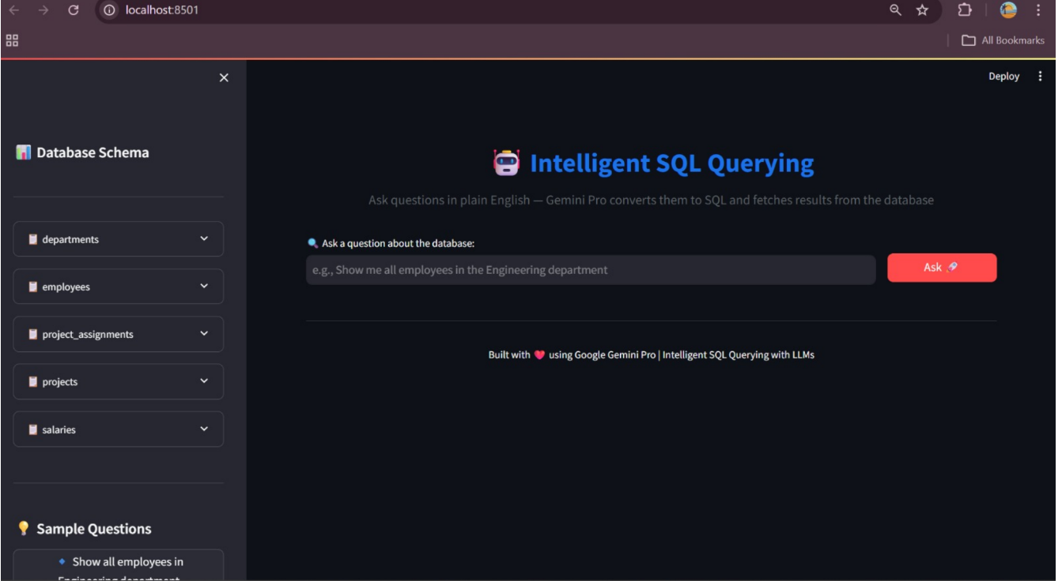
 | Data Preprocessing | 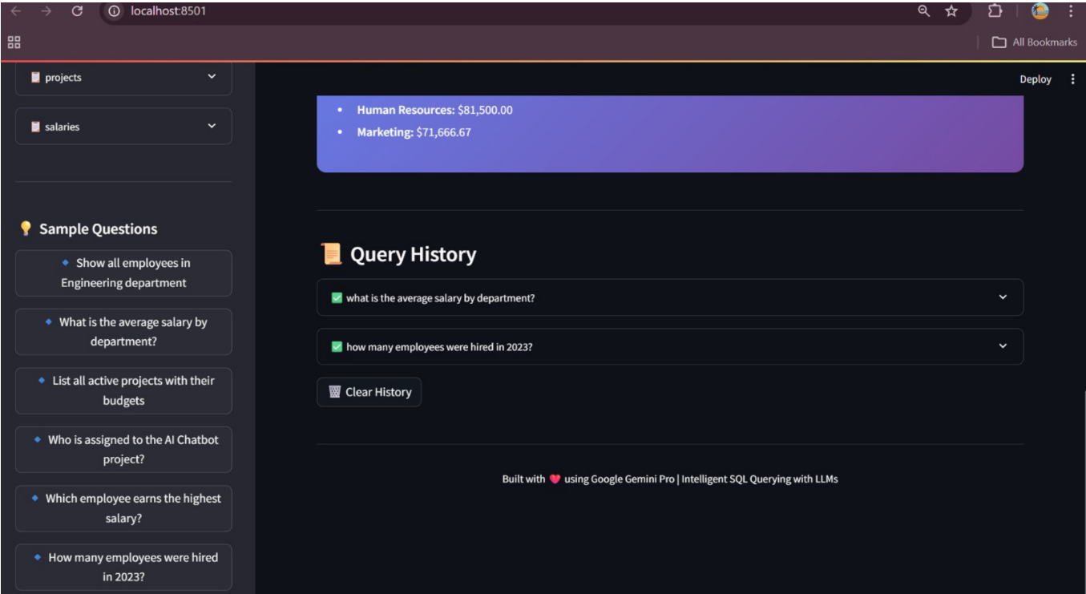
3. | Utilization of Data Filters | 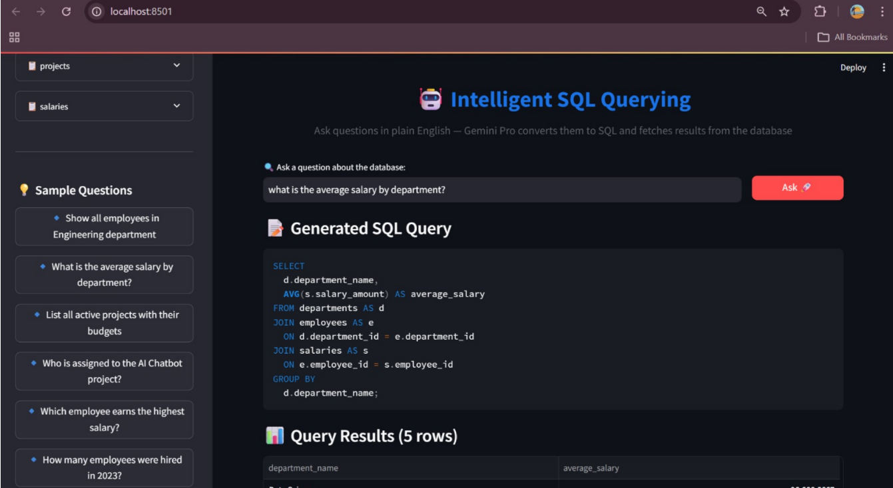
4. | DAX Queries Used | 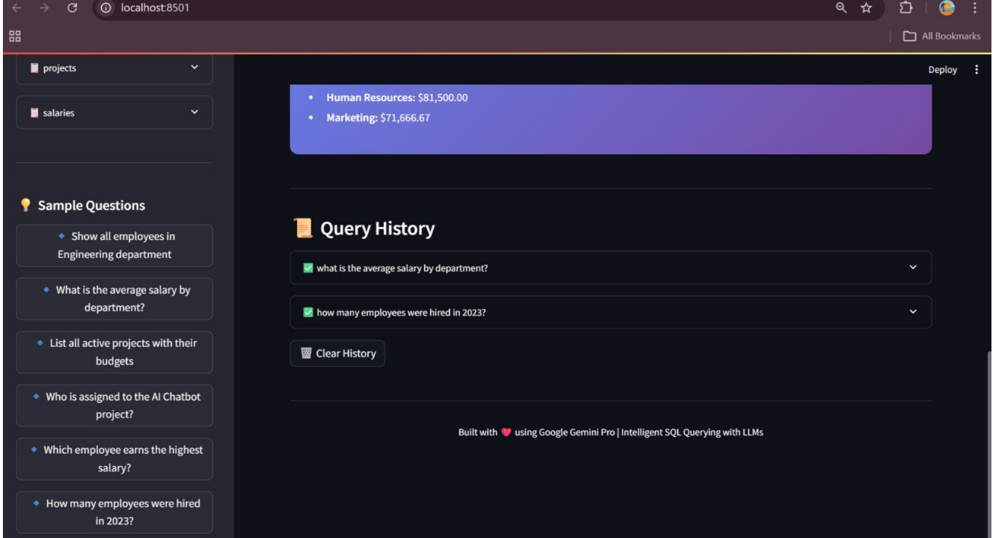
5. | Dashboard design | No of Visualizations / Graphs -
6 | Report Design | No of Visualizations / Graphs -

